

COS40007
Studio 1 - 3
Duc Thuan Tran|104330455
Portfolio Assessment 3

Overview
This project developed an AI model to classify vegemite consistency levels using machine process data. After preprocessing the dataset (removing constant columns, converting low variance features to categorical, applying SMOTE for class balancing), multiple classification models were evaluated. The Random Forest classifier achieved superior performance with 99.4% accuracy on the balanced test set. Decision rules extracted from the model identified optimal machine setting ranges for each consistency level, translating complex AI insights into actionable production guidelines. The project demonstrates how machine learning can effectively optimize food manufacturing processes through accurate prediction and practical operational recommendations.

Source:

Step1: Data Preparation

Initial Data Exploration and Understanding
The vegemite.csv dataset contains machine process and machine settings data related to vegemite production. Before applying any machine learning techniques, I conducted a thorough exploration of the dataset to understand its structure and characteristics.
The initial exploration revealed that the dataset contains 15,237 records with 47 features. These features represent various machine process parameters and settings that affect the consistency of vegemite production. The target variable 'Class' contains three values (0, 1, 2) representing different consistency levels of solids in vegemite production.

Class Distribution Analysis
The distribution of the target variable is a critical aspect of any classification problem. An initial analysis of the class distribution (Figure 1) revealed an imbalance:
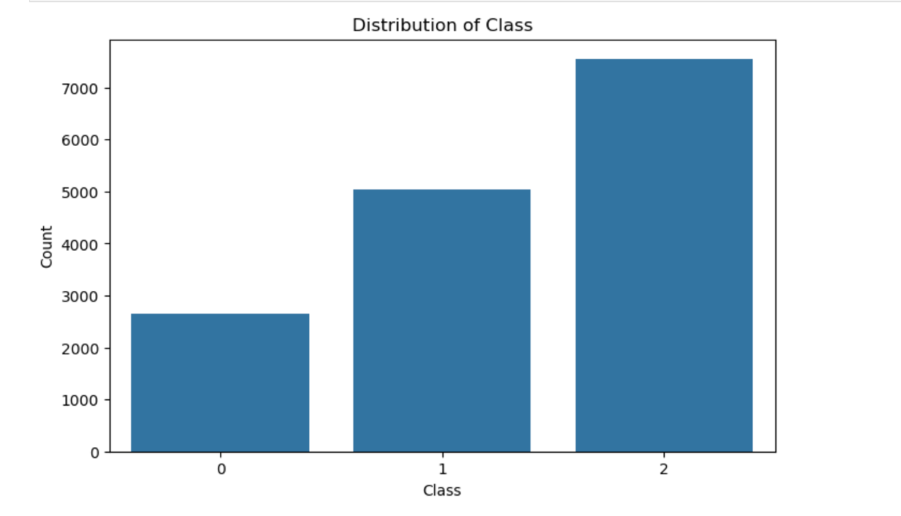
Image 1. Class Distribution
Class Distribution:
- Class 2: 7,548 samples (49.5%)
- Class 1: 5,047 samples (33.1%)
- Class 0: 2,642 samples (17.3%)
This distribution shows that Class 0 (representing one specific consistency level) is significantly underrepresented compared to the other classes. This imbalance could potentially bias our model toward the majority classes if not addressed appropriately.

Shuffling the Dataset
To ensure randomness in data selection, I first shuffled the entire dataset:
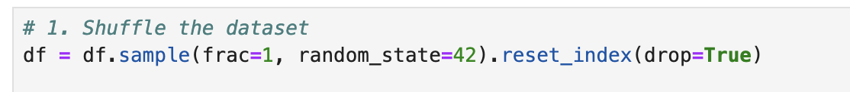
Image 2. Shuffle the dataset
Using a random state of 42 ensures reproducibility while maintaining the benefits of randomization.

Creating a Balanced Test Set
Following the assignment requirements, I extracted 1,000 data points for testing with a balanced distribution across classes:
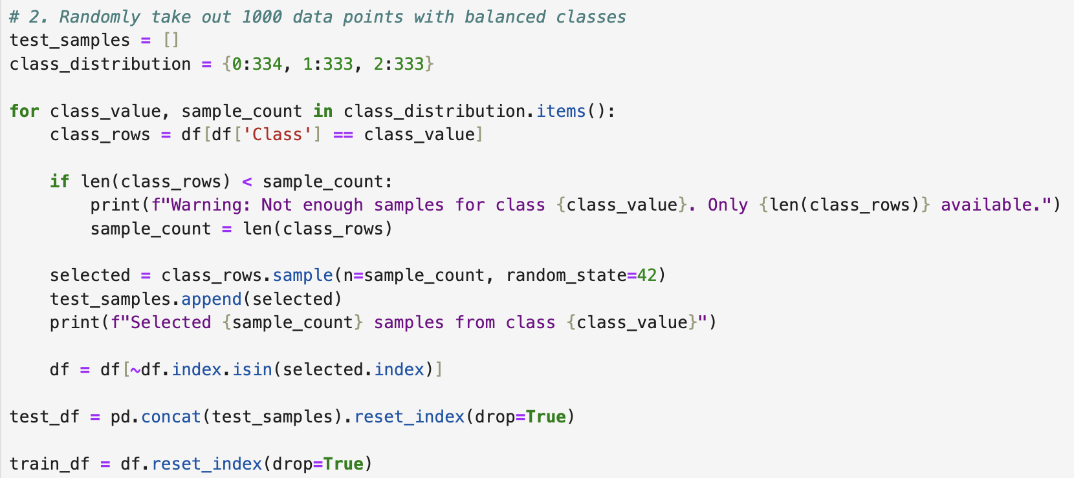
Image 3. Creating Balanced Test Set

The test dataset now contains:
- 334 samples from Class 0
- 333 samples from Class 1
- 333 samples from Class 2
This balanced distribution in the test set ensures fair evaluation across all classes. The remaining 14,237 data points form the training set.

Feature Construction and Cleaning

1. Removing Constant Value Columns
Constant value columns provide no discriminative information for classification and can be safely removed:
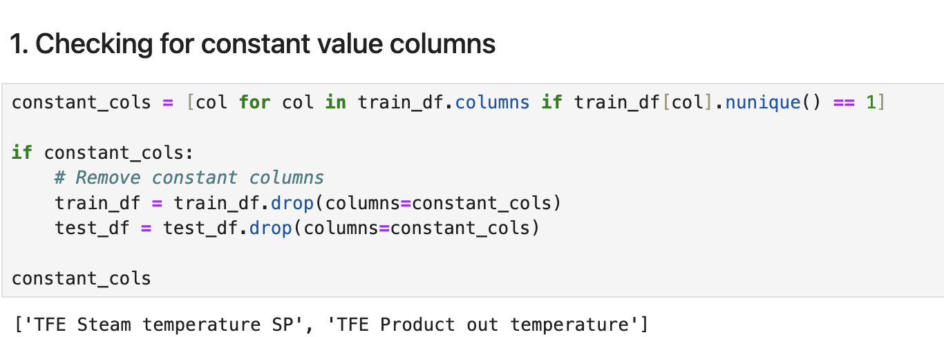
Image 4. Removing Constant Value Columns

Two columns were identified as constant and removed:
- 'TFE Steam temperature SP'
- 'TFE Product out temperature'

2. Converting Columns with Few Integer Values to Categorical
Numeric columns with few unique values are often better treated as categorical features:
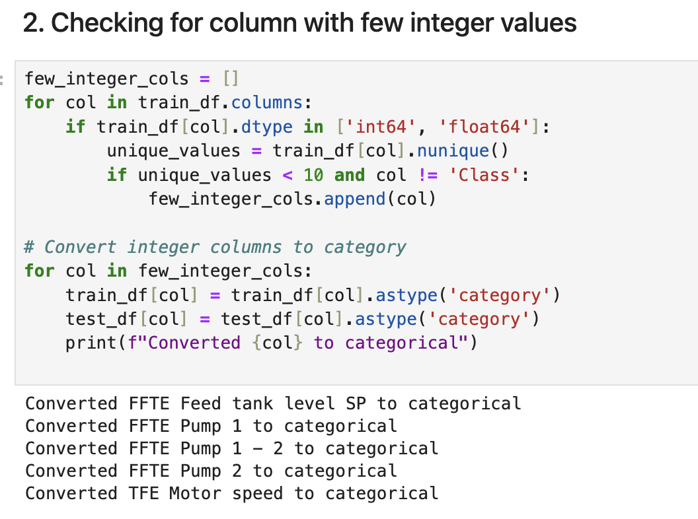
Image 5. Converting columns with few integer values to categorical
Five columns were converted to categorical type:
- FFTE Feed tank level SP (3 unique values)
- FFTE Pump 1 (5 unique values)
- FFTE Pump 1 - 2 (4 unique values)
- FFTE Pump 2 (5 unique values)
- TFE Motor speed (3 unique values)
3. Training Set Class Distribution:
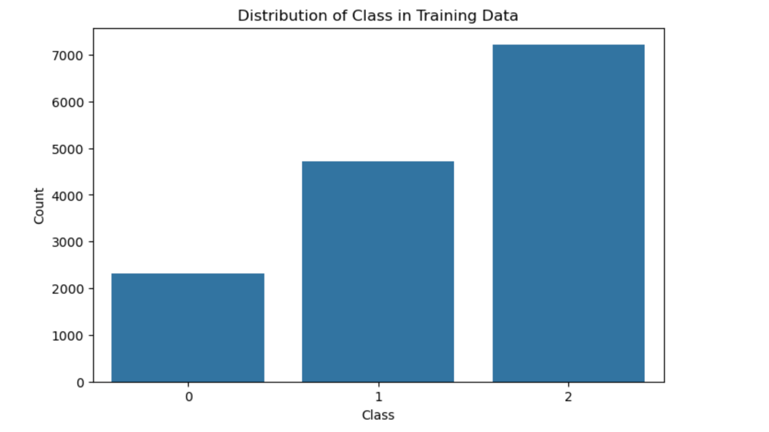
Image 6. Class distribution in training data
- Class 2: 7,215 samples
- Class 1: 4,714 samples
- Class 0: 2,308 samples
To quantify this imbalance, I calculated the imbalance ratio:
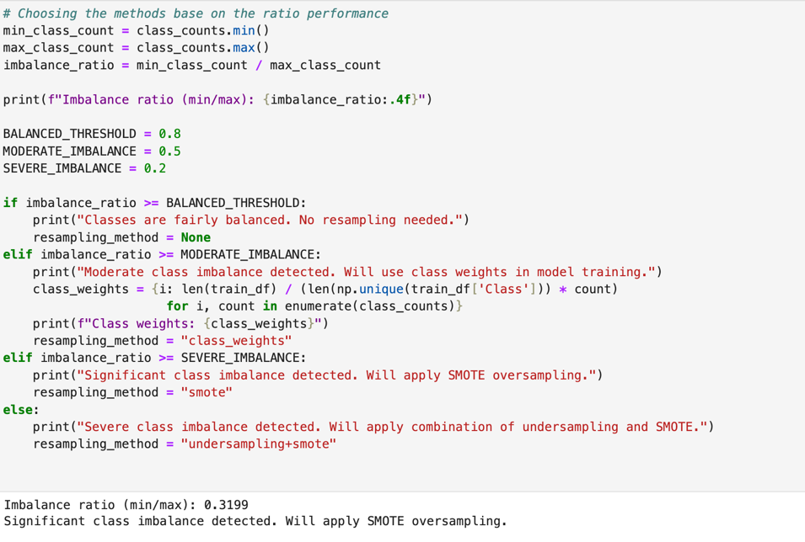
Image 7. Imbalance ratio calculation
With an imbalance ratio of 0.3199, the SMOTE (Synthetic Minority Over-sampling Technique) method was selected to address the class imbalance.
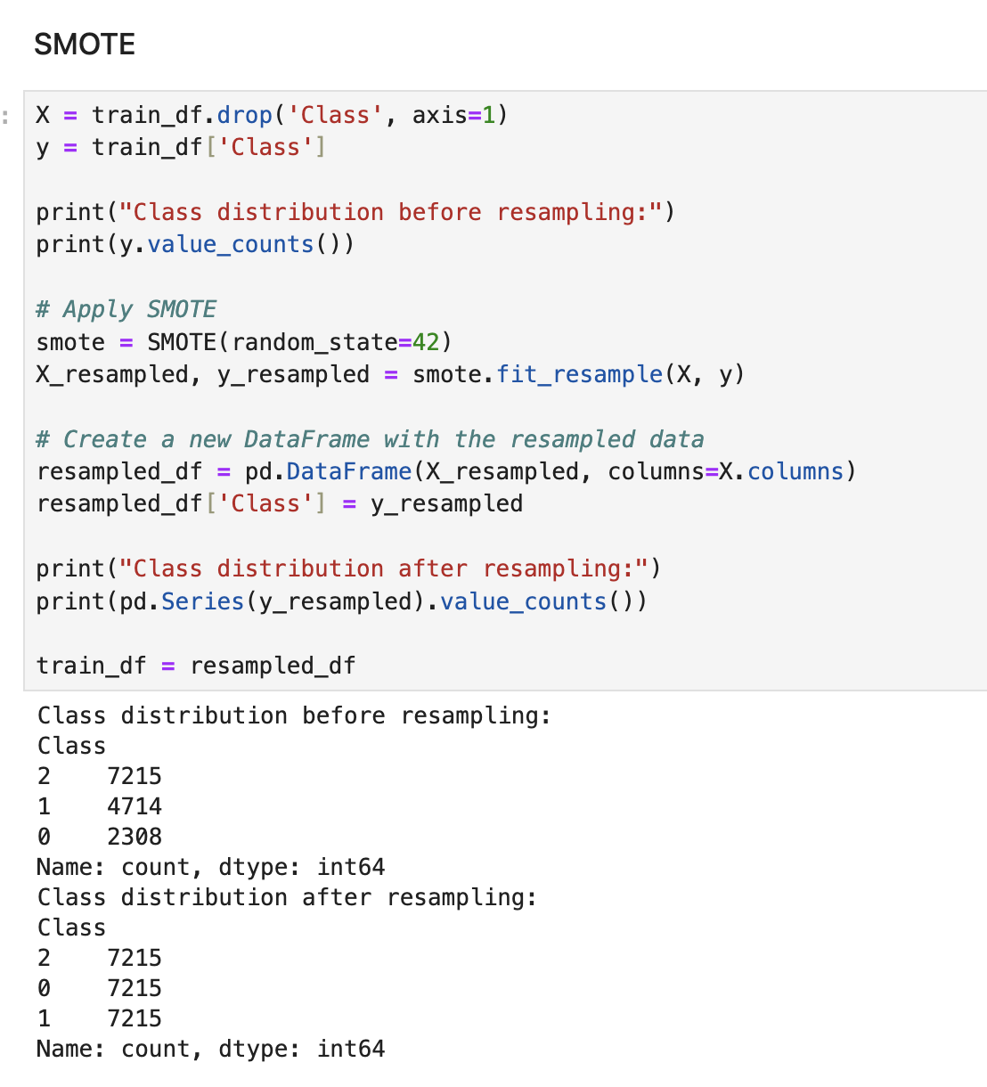
Image 8. Smote applying for class imbalance
After applying SMOTE, the training dataset had a perfectly balanced class distribution with 7,215 samples in each class.
By systematically addressing data preparation requirements, I created a solid foundation for feature selection and model training in subsequent steps. The balanced test set will provide a fair evaluation of model performance, while the SMOTE-balanced training set will help prevent bias toward majority classes during model training.

4. Exploring Composite Features Through Correlation Analysis
To identify potentially useful composite features, I conducted a correlation analysis to understand relationships between variables. This approach helps identify features that might work well together or could be combined to create more informative features.
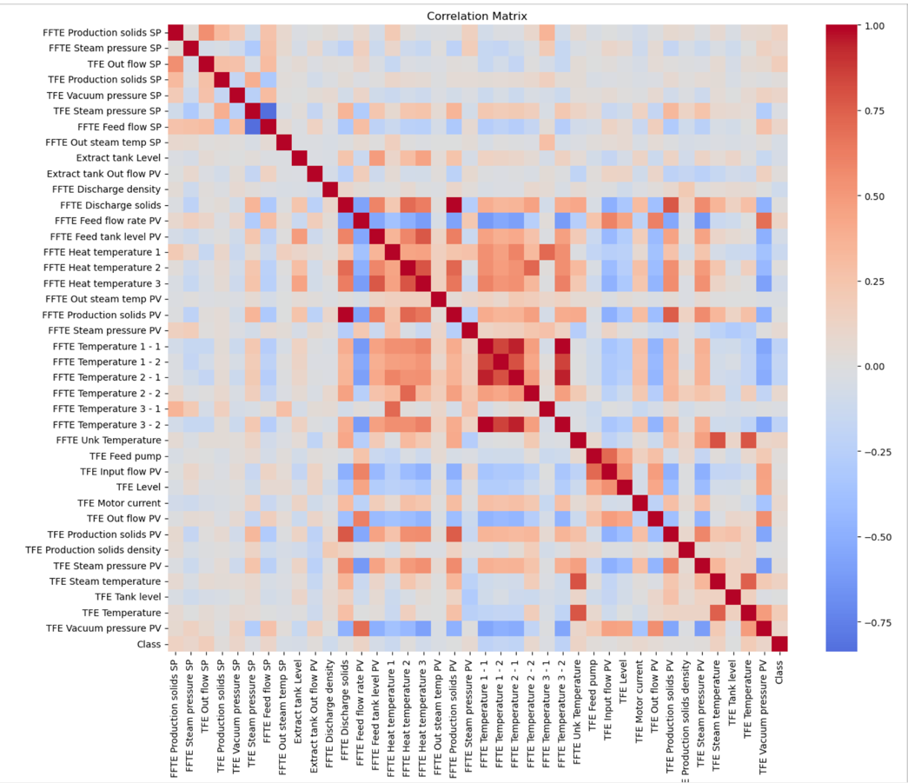
Image 9. Correlation Analysis
The correlation matrix (shown in Image 3) revealed several interesting patterns:
- Strong correlations between certain set points (SP) and their corresponding process variables (PV)
- Moderate correlations between temperature measurements at different points in the process
- Notable correlations between feed flow and pressure parameters
Based on these observations, I created three types of composite features:
- Temperature Averaging:
Several temperature sensors showed high correlation, suggesting they measure related aspects of the process. Averaging these readings provides a more robust temperature indicator:
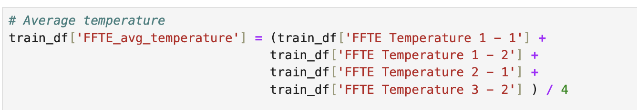
Image 10. Temperature Averaging
- Flow-Pressure Ratio:
The correlation between feed flow and steam pressure suggested an important relationship. Creating a ratio feature captures this relationship:
Image 11. Flow-Pressure Ratio

- Setpoint-Process Variable Deviations:
The difference between setpoints (target values) and process variables (actual values) can indicate how well the process is controlled:
Image 12. Setpoint-process variable deviations

5. Final Feature Count
After completing all the data preparation steps, I tallied the final feature count:
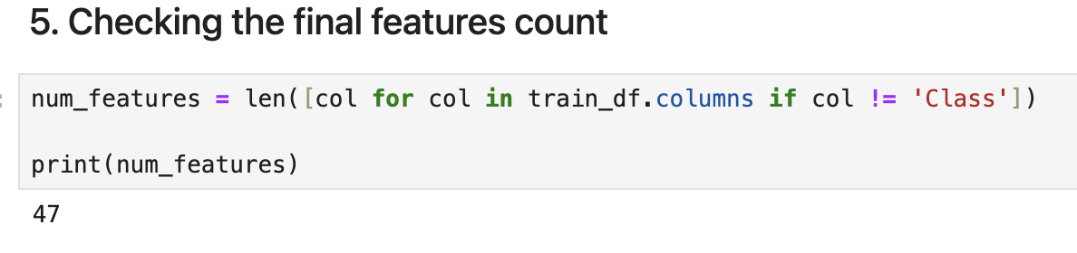
Image 13. Final features count
The final dataset contains 47 features (excluding the target 'Class' column). This count includes:
- Original features remaining after removing constant columns
- Categorical features converted from numeric columns with few integer values
- Newly created composite features based on correlation analysis
The feature count suggests a moderately complex dataset with sufficient information for model training while not being excessively high-dimensional.

Step2: Feature Selection, Model Training and Evaluation

Feature Selection with SelectKBest
After preparing the dataset in Step 1, I proceeded to select the most relevant features for model training. Feature selection is crucial for improving model performance, reducing overfitting, and decreasing computational complexity.
I implemented a systematic approach using the SelectKBest method with the f_classif scoring function, which employs ANOVA F-value to identify features with the strongest relationship to the target variable.
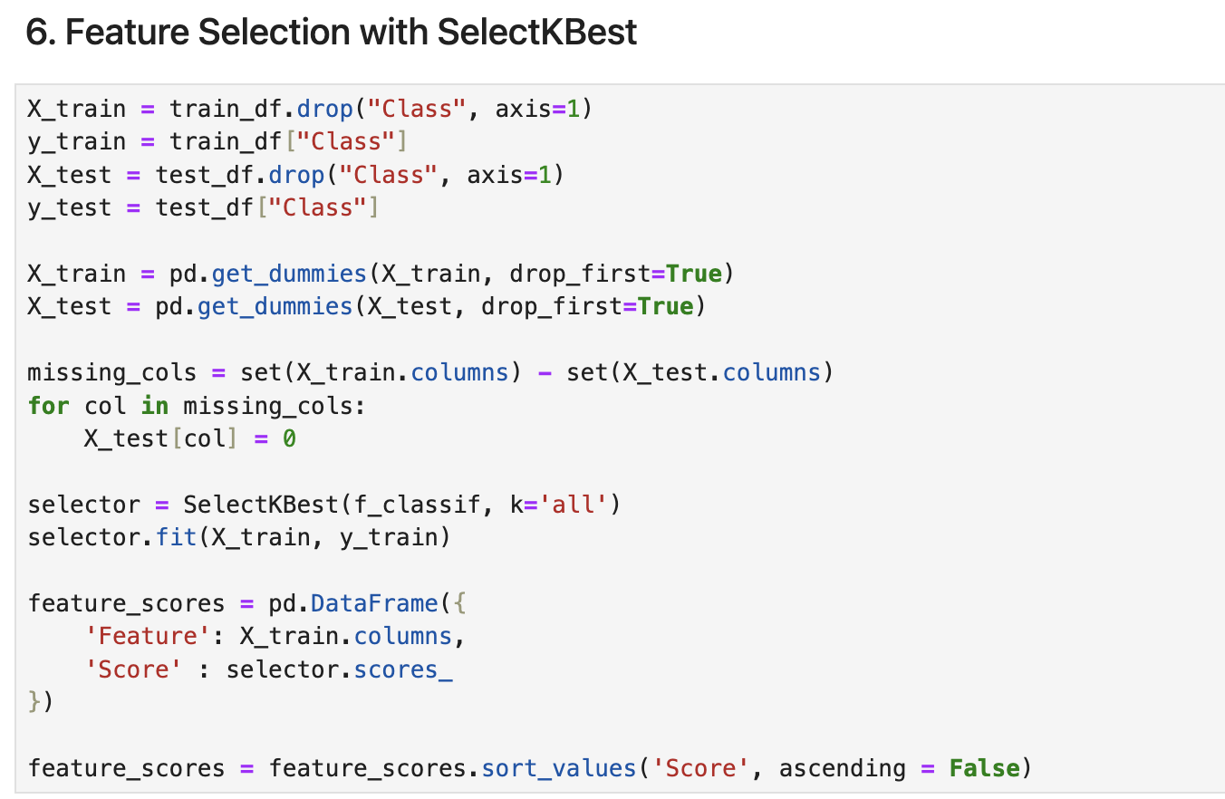
Image 14. Feature Selection with SelectKBest
After analyzing the feature importance scores, I selected the top 20 features that collectively provided the most discriminative power for the classification task:
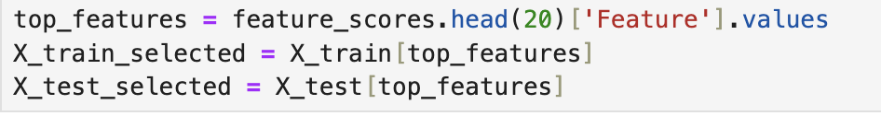
Image 15. Select 20 best features base on the score.

Model Training and Evaluation
With the selected features, I trained multiple machine learning models to compare their performance. As required by the assignment, I included DecisionTreeClassifier and added four other models to provide a comprehensive comparison:
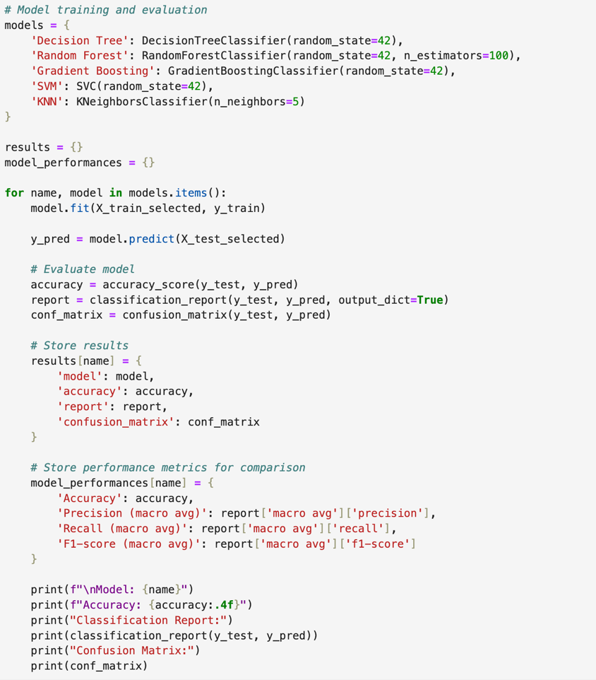
Image 16. Model Training & Model Evaluating
Each model was evaluated using multiple metrics to provide a comprehensive assessment of their performance:
- Accuracy: The proportion of correct predictions among the total number of predictions.
- Precision: The ability of the model to avoid false positives (proportion of true positives among all positive predictions).
- Recall: The ability of the model to find all positive samples (proportion of true positives among all actual positives).
- F1-score: The harmonic mean of precision and recall, providing a balance between the two metrics.
- Confusion Matrix: A table showing the number of true positives, false positives, true negatives, and false negatives for each class.

Model Comparison
To facilitate comparison between models, I created a comparison table with all performance metrics, The model comparison yielded the following results:
Model | Accuracy | Precision | Recall | F1-score
Decision Tree | 0.840 | 0.850 | 0.840 | 0.839
Random Forest | 0.994 | 0.994 | 0.994 | 0.994
Gradient Boosting | 0.882 | 0.881 | 0.881 | 0.881
SVM | 0.473 | 0.576 | 0.472 | 0.396
KNN | 0.903 | 0.902 | 0.902 | 0.902

Best Model Selection
After comparing all models across different evaluation metrics, I selected the best-performing model based on the F1-score, which provides a balanced measure of precision and recall. The Random Forest classifier emerged as the best-performing model with an impressive F1-score of 0.9940. This model demonstrated exceptional performance across all metrics:
Image 17. Best Model Result

Model Saving
To preserve the best model for future use, I saved it using the pickle library
Image 18. Model Saving

Step 3: ML to AI
In this step, I transformed the trained machine learning model into a functioning AI system by deploying it to make predictions on new, unseen data. This process involved loading the saved model, preparing the test data, making predictions, and evaluating the model's performance in a real-world context. First, I loaded the best-performing model (Random Forest) that was saved during Step 2. The output confirmed successful loading of the RandomForestClassifier with the correct parameters:
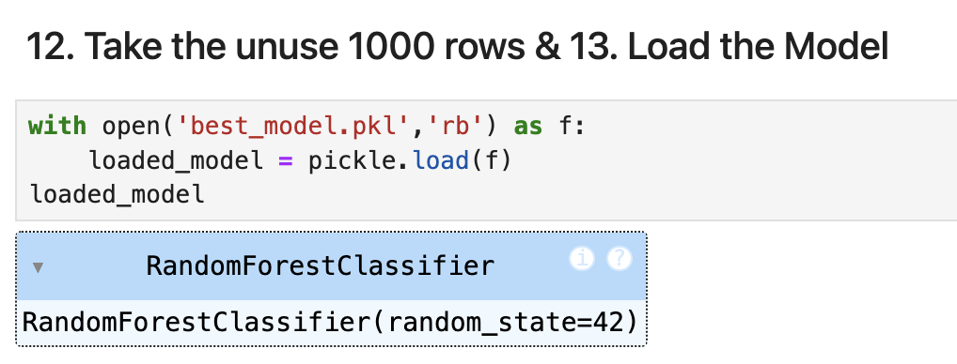
Image 19. Load the model
To ensure consistent processing, I prepared the test data with the same feature format used during training. With the model loaded and test data prepared, I made predictions on the 1,000 unseen test samples

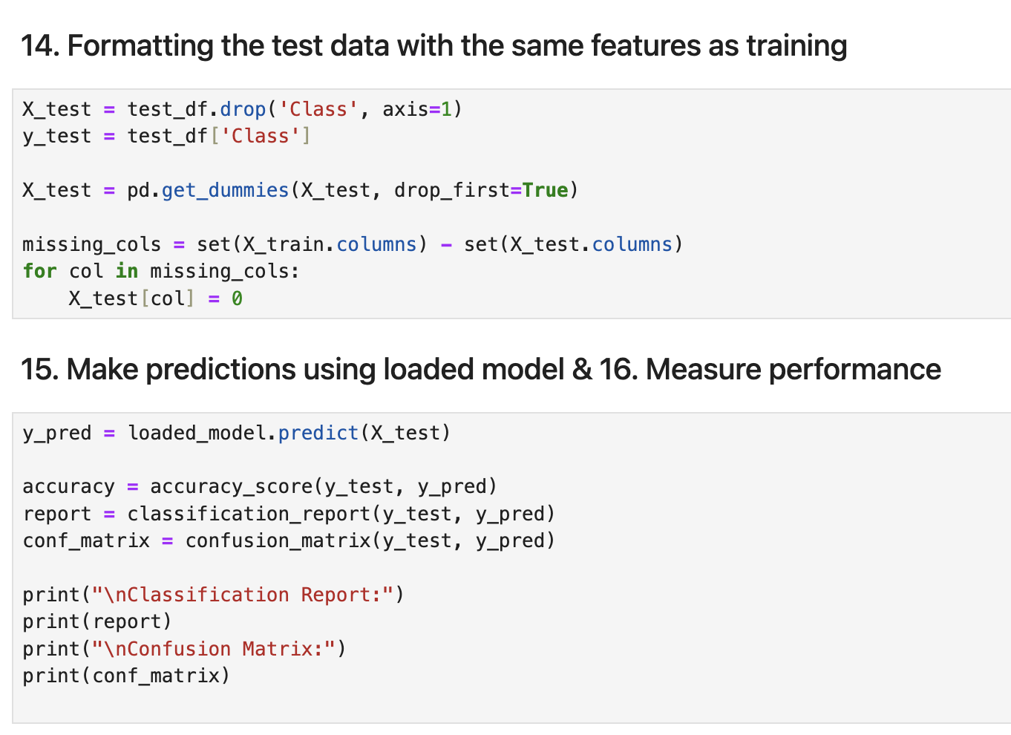
Image 20. Formatting Test as training, Make prediction, Measure Performance

The model achieved outstanding performance on the unseen test data:

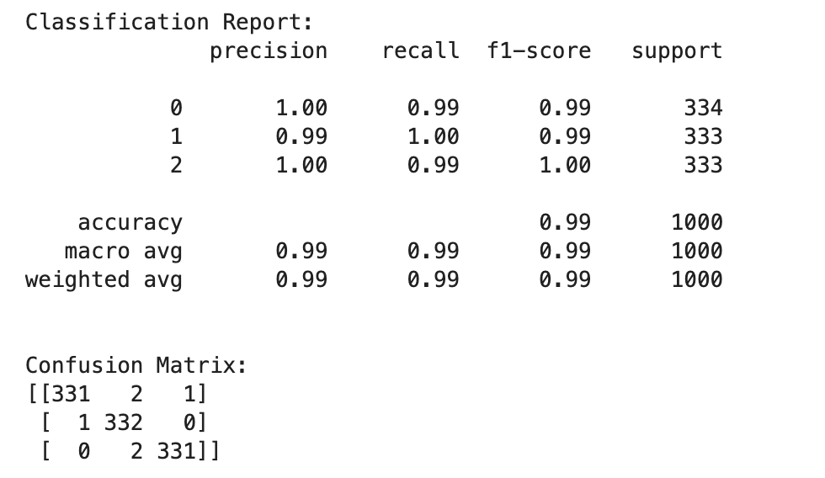
Image 21. Classification report and Confusion Matrix

I visualized the confusion matrix to provide a clearer understanding of the model's performance across different classes:
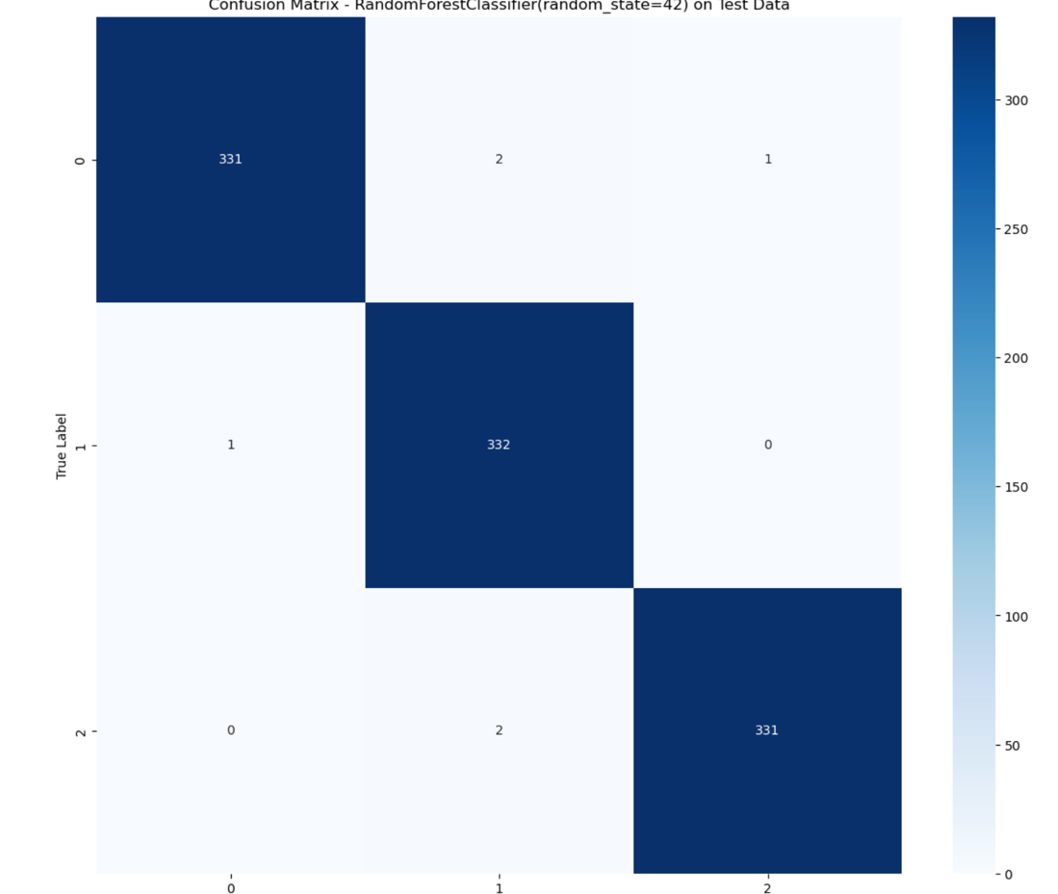
Image 22. Confusion Matrix Heat Map
The visualization (Image 2) shows that the model correctly classified most samples, with only 6 misclassifications out of 1,000 test samples. This represents a 99.4% accuracy rate on completely unseen data, demonstrating the model's strong generalization capabilities.

Evaluating All Models on the Test Set
To validate our model selection and ensure the Random Forest remained the best choice, I evaluated all trained models on the test dataset:
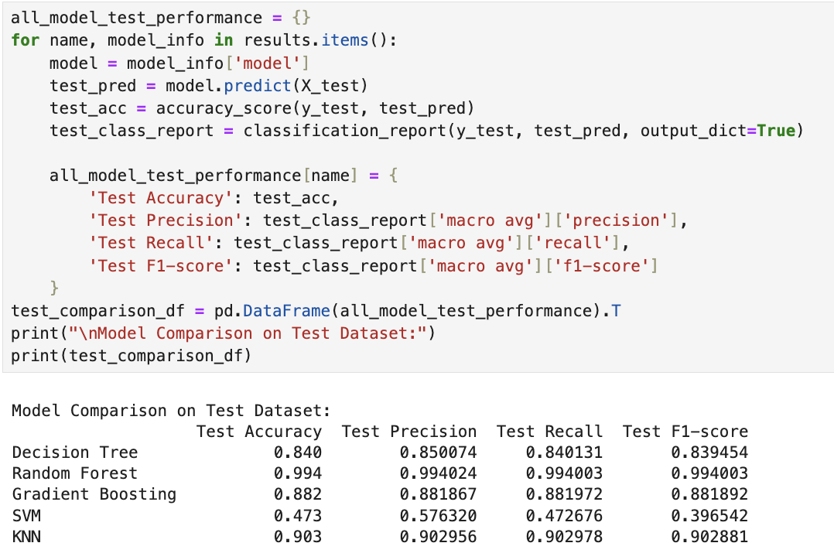
Image 22. Evaluating the best model on test set
Model | Accuracy | Precision | Recall | F1-score
Decision Tree | 0.840 | 0.850 | 0.840 | 0.839
Random Forest | 0.994 | 0.994 | 0.994 | 0.994
Gradient Boosting | 0.882 | 0.881 | 0.881 | 0.881
SVM | 0.473 | 0.576 | 0.472 | 0.396
KNN | 0.903 | 0.902 | 0.902 | 0.902
Base on the table output: Random Forest is the best model on the test set

Step 4: Develop rules from the ML model
The final step of this project involved extracting actionable rules from the machine learning model to guide vegemite production parameters. This step is particularly valuable as it transforms the "black box" nature of complex ML models into clear, interpretable guidelines that can be directly implemented by production staff.

Extracting Set Point (SP) Features
First, I focused exclusively on the set point (SP) features, which represent the controllable parameters in vegemite production:
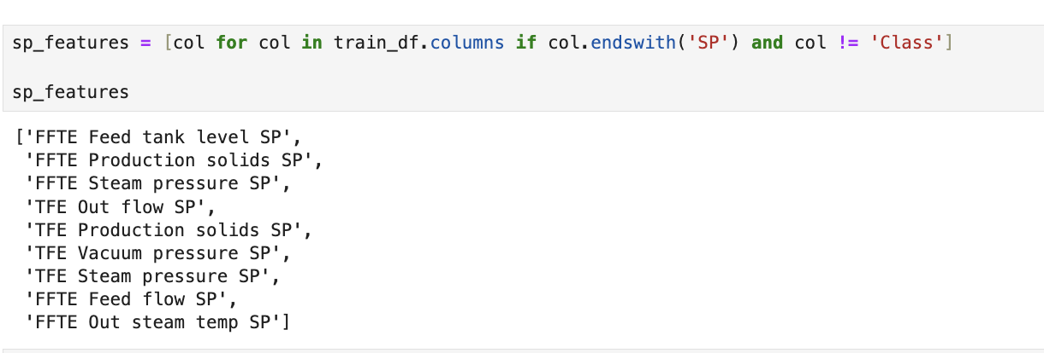
Image 23. Extracting Set Point (SP) Features

Building a Decision Tree Model with SP Features Only
Using only these controllable parameters, I created a dataset focused on SP features and trained a decision tree model:
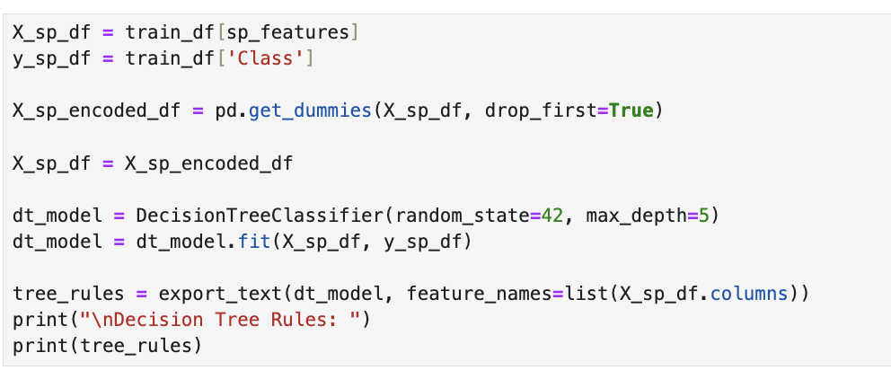
Image 24. Building a Decision Tree Model with SP Features Only
I intentionally limited the tree depth to 5 to create rules that are both interpretable and practical. Deeper trees might provide higher accuracy but would produce overly complex rules that would be difficult to implement in a production environment.

Analyzing the Decision Rules
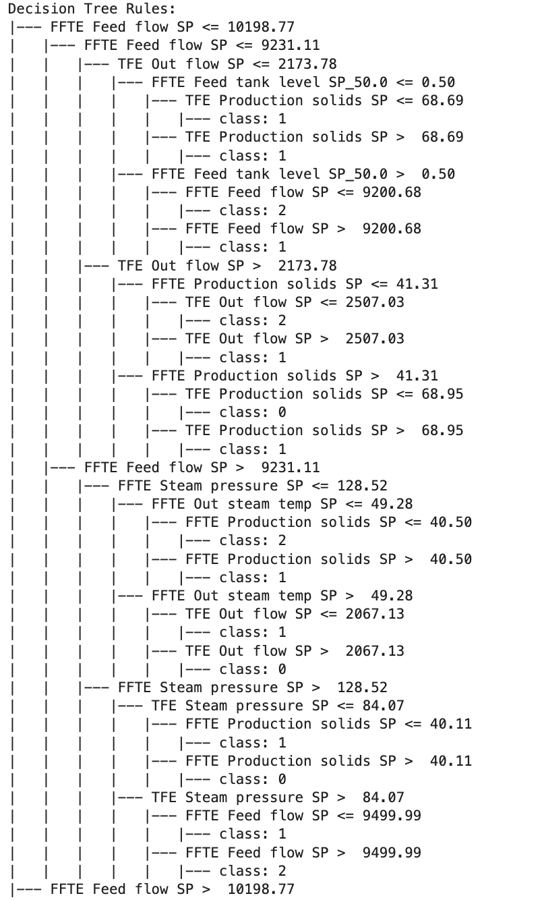
Image 25. Decision Tree result part 1
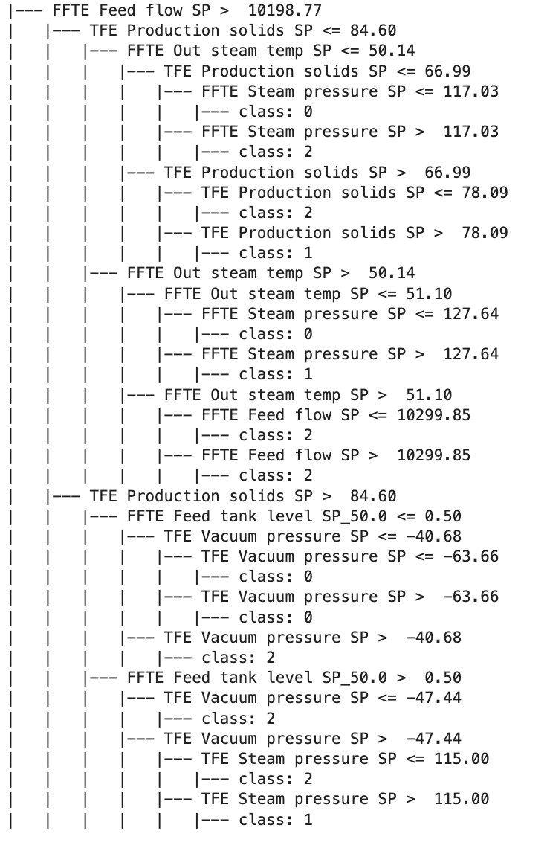
Image 26. Decision Tree result part 2

The resulting decision tree provides clear pathways from set point configurations to expected consistency classes. From the tree structure, I extracted the following key rules for each class:

For Class 0 (Low consistency):
- If FFTE Feed flow SP > 9231.11 AND FFTE Steam pressure SP > 128.52 AND TFE Steam pressure SP <= 84.07 AND FFTE Production solids SP > 40.11
- If FFTE Feed flow SP <= 9231.11 AND TFE Out flow SP > 2173.78 AND FFTE Production solids SP > 41.31 AND TFE Production solids SP <= 68.95
- If FFTE Feed flow SP > 10198.77 AND TFE Production solids SP <= 84.60 AND FFTE Out steam temp SP <= 50.14 AND TFE Production solids SP <= 66.99 AND FFTE Steam pressure SP <= 117.03

For Class 1 (Medium consistency):
- If FFTE Feed flow SP <= 9231.11 AND TFE Out flow SP <= 2173.78 AND FFTE Feed tank level SP <= 0.50 AND TFE Production solids SP <= 68.69
- If FFTE Feed flow SP <= 9231.11 AND TFE Out flow SP > 2173.78 AND FFTE Production solids SP <= 41.31 AND TFE Out flow SP > 2507.03
- If FFTE Feed flow SP > 9231.11 AND FFTE Steam pressure SP <= 128.52 AND FFTE Out steam temp SP > 49.28 AND TFE Out flow SP <= 2067.13

For Class 2 (High consistency):
- If FFTE Feed flow SP <= 9231.11 AND TFE Out flow SP <= 2173.78 AND FFTE Feed tank level SP > 0.50 AND FFTE Feed flow SP <= 9200.68
- If FFTE Feed flow SP > 9231.11 AND FFTE Steam pressure SP <= 128.52 AND FFTE Out steam temp SP <= 49.28 AND FFTE Production solids SP <= 40.50
- If FFTE Feed flow SP > 10198.77 AND TFE Production solids SP <= 84.60 AND FFTE Out steam temp SP <= 50.14 AND TFE Production solids SP <= 66.99 AND FFTE Steam pressure SP > 117.03

Simplified Production Guidelines
Based on these decision rules, I formulated the following simplified guidelines for process operators:
For Class 0 (Low consistency) production:
- Keep FFTE Production solids SP above 40.11 but below 41.31
- Maintain TFE Production solids SP below 68.95
- Set FFTE Steam pressure SP below 117.03
- Target FFTE Feed flow SP above 9231.11 but below 10198.77
For Class 1 (Medium consistency) production:
- Set TFE Production solids SP between 68.69 and 78.09
- Maintain FFTE Feed tank level SP below 0.50
- Keep TFE Out flow SP above 2507.03 when FFTE Production solids SP is low
- Set FFTE Out steam temp SP between 49.28 and 51.10
For Class 2 (High consistency) production:
- Set FFTE Feed tank level SP above 0.50
- Keep FFTE Feed flow SP below 9200.68
- Maintain FFTE Production solids SP below 40.50
- Set FFTE Steam pressure SP above 117.03 but below 127.64
- Keep TFE Vacuum pressure SP above -47.44

Appendix: Source Code Repository
The complete source code for this project is available at the following link:

References
https://scikit-learn.org/stable/modules/model_evaluation.html

https://scikit-learn.org/stable/modules/model_evaluation.html#classification-report

https://scikit-learn.org/stable/modules/model_evaluation.html#confusion-matrix

https://datasciencehorizons.com/handling-imbalanced-datasets-in-scikit-learn-techniques-and-best-practices/

https://scikit-learn.org/stable/modules/generated/sklearn.feature_selection.mutual_info_classif.html#sklearn.feature_selection.mutual_info_classif

https://www.datacamp.com/tutorial/random-forests-classifier-python

https://medium.com/intuition/gradient-descent-visualization-285d3dd0fe00

